Quickstart for VMD+SYVA

**1. Download and Install VMD 1.9.3**

Choose the operating system for your VMD installation. It is highly recommended to download the software from VMD Home page (<https://www.ks.uiuc.edu/Development/Download/download.cgi?PackageName=VMD>).

Select the version that is compatible with your operating system. At this time the latest stable version is 1.9.3. There is also Version 1.9.4 ALPHA. But Version 1.9.3 is recommended, and it is also very easy to install.

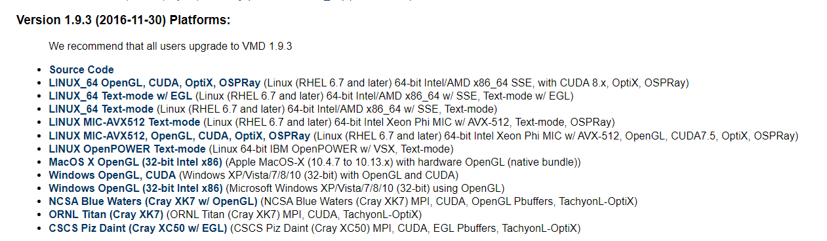

**2. Install plugins**

Unzip the plugins.zip file and copy the following three files (symm.exe, libgcc_s_seh-1.dll, and libquadmath-0.dll) to the root directory of your VMD (e.g. D:\sync\program\VMD). Copy symm.tcl to ***\VMD\plugins\noarch\tcl\symmetrytool1.3.

Note *** represents the root directory of your VMD.

**3. Load molecule and show symmetry**

Open VMD, drag the molecules in the Resources folder into the VMD window and select Extensions -> Analysis -> Symmetry Tool.

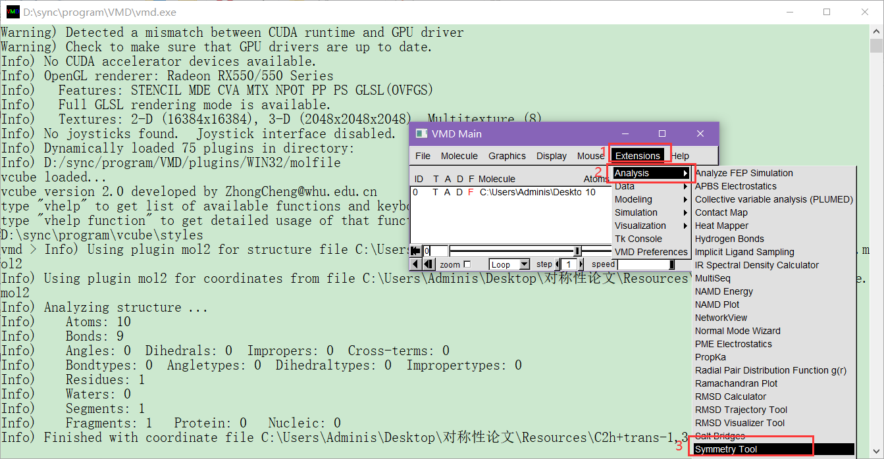

Then, in the SymmetryTool window that pops up, click on the Guess-Symmetry button to get a display of symmetry elements and point groups.